# BORIS GIBSON

*AFL-CIO President*

USW Local 7898

919.909.8515

[aflciopresidentsc@gmail.com](mailto:aflciopresidentsc@gmail.com)

# JAMES DUKES

*AFL-CIO Financial Secretary/Treasurer*

Boilermakers Local 456

706.399.8768

[dukesjames66@gmail.com](mailto:dukesjames66@gmail.com)

# KIM L. SMITH

*AFL-CIO Vice President*

USW Staff Representative

843.302.6410

[klsmith@usw.org](mailto:klsmith@usw.org)

# JAMES C. HALL

*AFL-CIO Vice President*

SMART Local 399

843.209.2457

[Hallj8568@gmail.com](mailto:Hallj8568@gmail.com)

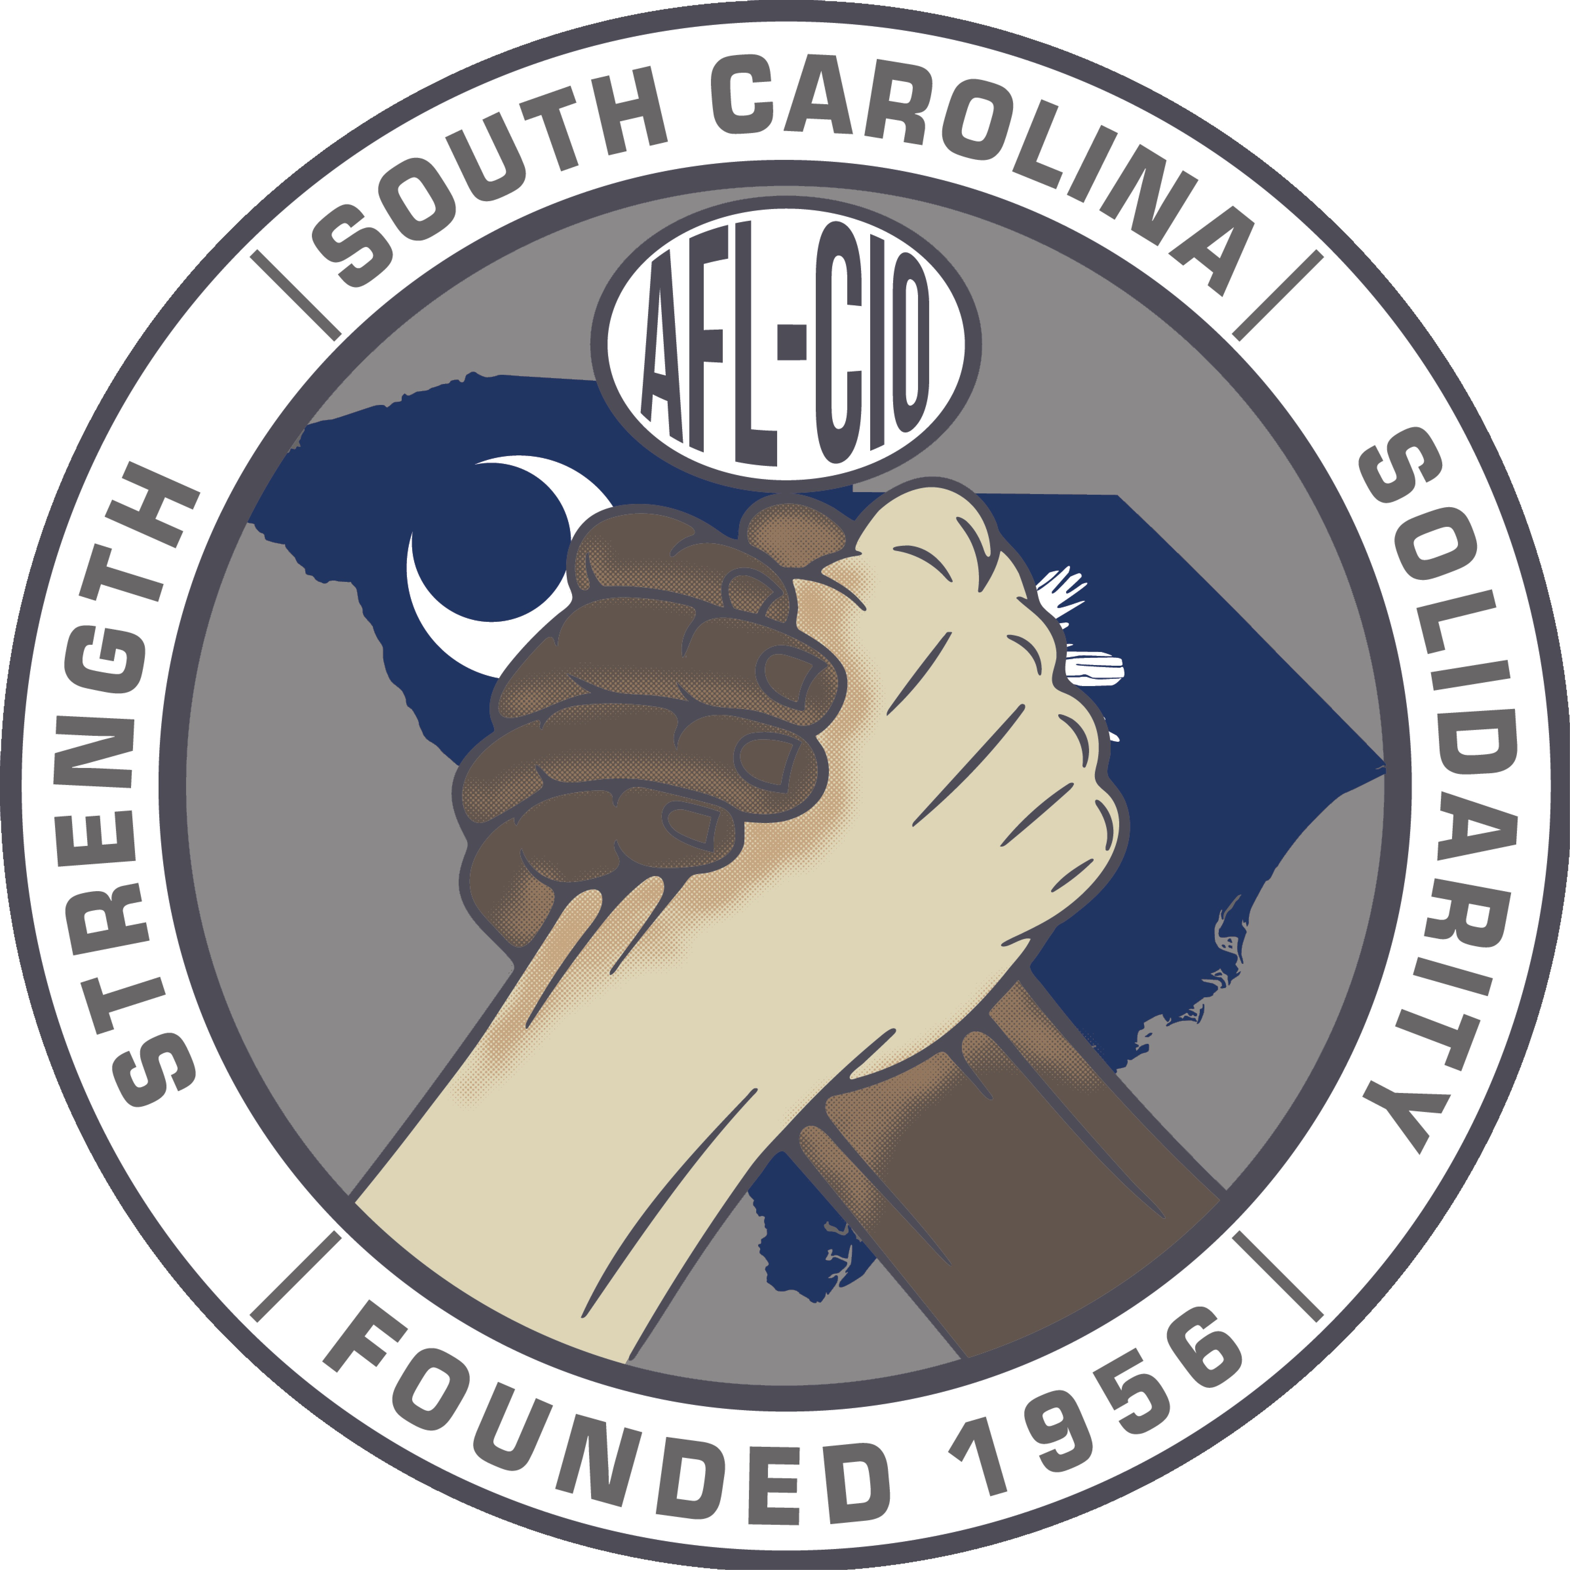SOUTH CAROLINA AFL-CIO

2999 Sunset Blvd. Suite 103 West Columbia, SC 29169 803.926.8680

February 19, 2025

Legislative Committee

SC AFL-CIO

2999 Sunset Blvd

West Columbia, SC 29169

Dear Brothers and Sisters,

As a leader of your organization and/or business, we are certain you understand the serious need for change in the state of South Carolina. Our organization, the South Carolina AFL-CIO is actively trying to ensure change occurs on behalf of all workers within the state.

We are reaching out to you for your support in helping us make the difference in the lives of everyone affected by erroneous laws, negative statements, and blatant attacks against labor and in particular the state of South Carolina.

We will be hosting a Legislative Conference on March 25 and 26, 2025 that will include educating, development, mobilization and a call to action.

We are asking you to stand in solidarity with us by purchasing a sponsorship ad in our program for the Legislative Conference. Following are the different levels of opportunity in which you can show your support:

Quarter page ad: $250

Half Page ad: $500

Full page ad: $1,000

To secure your ad today, please contact:

Jason Belton at (803) 977-0723 / beltondoesitbest2000@gmail.com or

James Smith at (803) 640-8399 / [smithjames1312@gmail.com](mailto:smithjames1312@gmail.com)

Any support you can provide will be greatly appreciated.

In solidarity,

SC AFL-CIO

Legislative Committee