BORIS GIBSON
AFL-CIO President
USW Local 7898
919.909.8515
aflciopresidentsc@gmail.com

JAMES DUKES
AFL-CIO Financial Secretary/Treasurer
Boilermakers Local 456
706.399.8768
dukesjames66@gmail.com

KIM L. SMITH
AFL-CIO Vice President
USW Staff Representative
843.302.6410
klsmith@usw.org

JAMES C. HALL
AFL-CIO Vice President
SMART Local 399
843.209.2457
Hallj8568@gmail.com

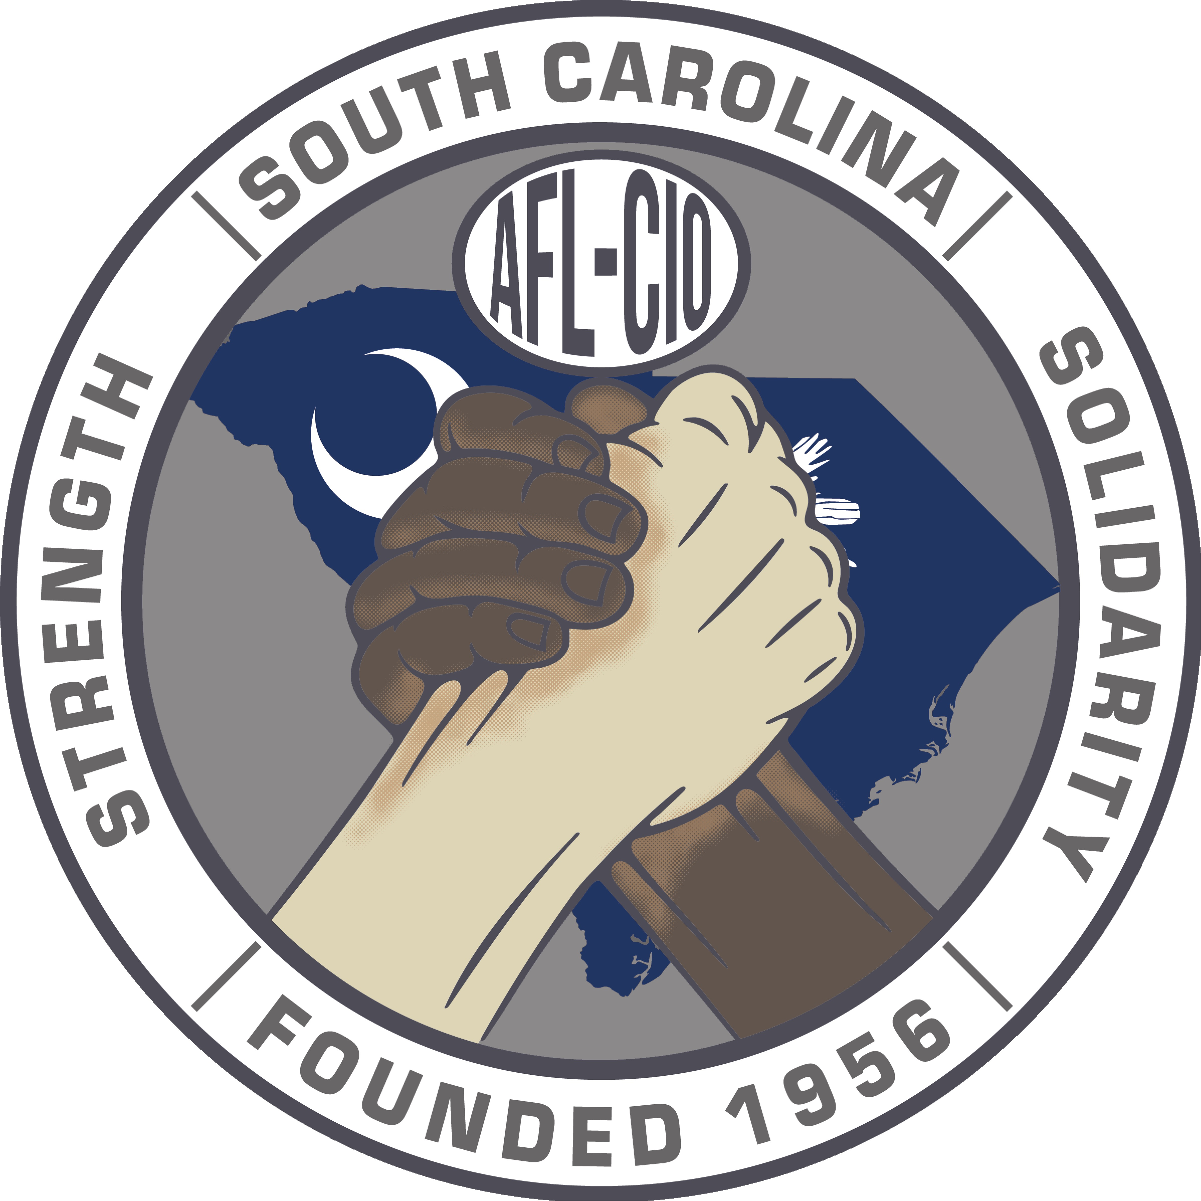
SOUTH CAROLINA AFL-CIO
2999 Sunset Blvd. Suite 103 West Columbia, SC 29169 803.926.8680

February 19, 2025

Legislative Committee
SC AFL-CIO
2999 Sunset Blvd
West Columbia, SC 29169

Dear Brothers and Sisters,
As a leader of your organization and/or business, we are certain you understand the serious need for change in the state of South Carolina. Our organization, the South Carolina AFL-CIO is actively trying to ensure change occurs on behalf of all workers within the state.

We are reaching out to you for your support in helping us make the difference in the lives of everyone affected by erroneous laws, negative statements, and blatant attacks against labor and in particular the state of South Carolina.

We will be hosting a Legislative Conference on March 25 and 26, 2025 that will include educating, development, mobilization and a call to action.

We are asking you to stand in solidarity with us by purchasing a sponsorship ad in our program for the Legislative Conference. Following are the different levels of opportunity in which you can show your support:

Quarter page ad: $250
Half Page ad: $500
Full page ad: $1,000

To secure your ad today, please contact:
Jason Belton at (803) 977-0723 / beltondoesitbest2000@gmail.com or
James Smith at (803) 640-8399 / smithjames1312@gmail.com

Any support you can provide will be greatly appreciated.

In solidarity,

SC AFL-CIO
Legislative Committee

